Final-version specification

WEBSCRP

Student Number: 617162

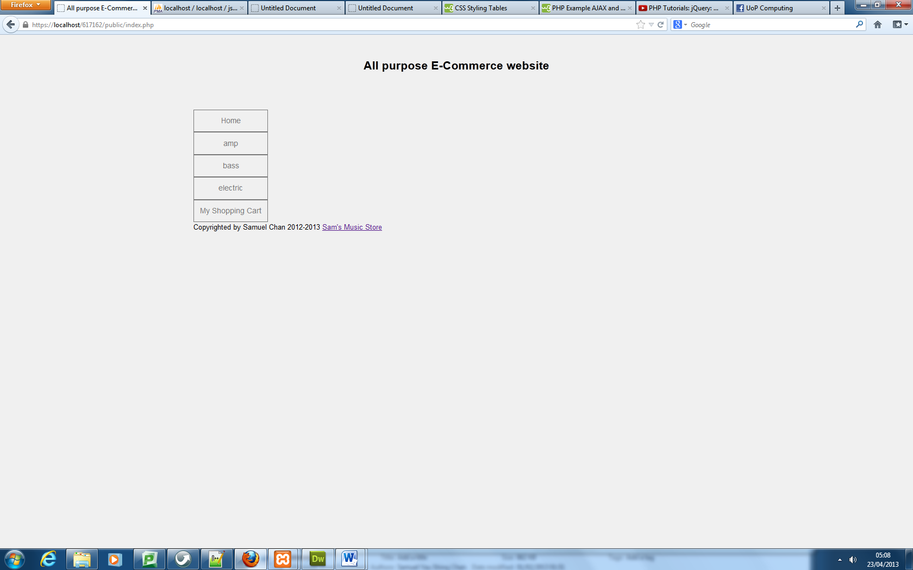Starting with the public pages, the clients customer is brought to the main page that has only a side navigation. A proposals of a news feed however was not finally implemented- explained later.

Main page

When no categories are set by the admin section, the home and shopping cart are the only options available to the user. The admin would have already added categories by this time so that the user has more links to choose from. When each category link is clicked, the user is brought to that specific page containing all the products that belong under that category. The navigation is brought to the side because it allows more categories to be added without it conflicting with other elements on the page. Details such as the product ID, name, description, price and quantity can be seen for the user to quickly scan and find the product they are looking for. The product name provides a method of accessing that products details and image where they are also able to add the product to cart. The cart allows users to store multiple products and change the quantity they wish to purchase. The option of removing the product from the cart is available as the cart will always calculate the total price of all existing products.

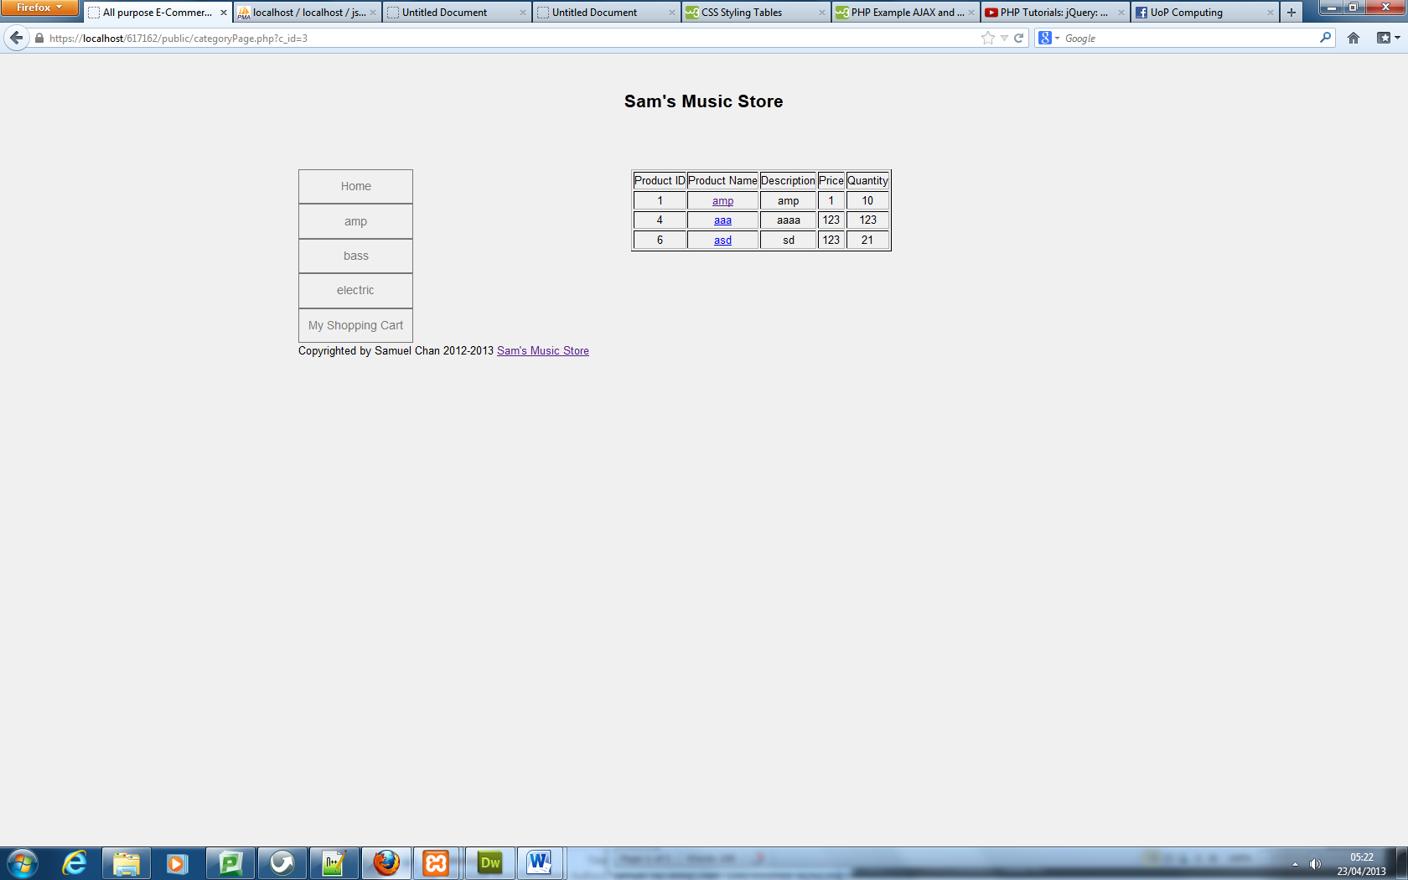

Products belong to a chosen category

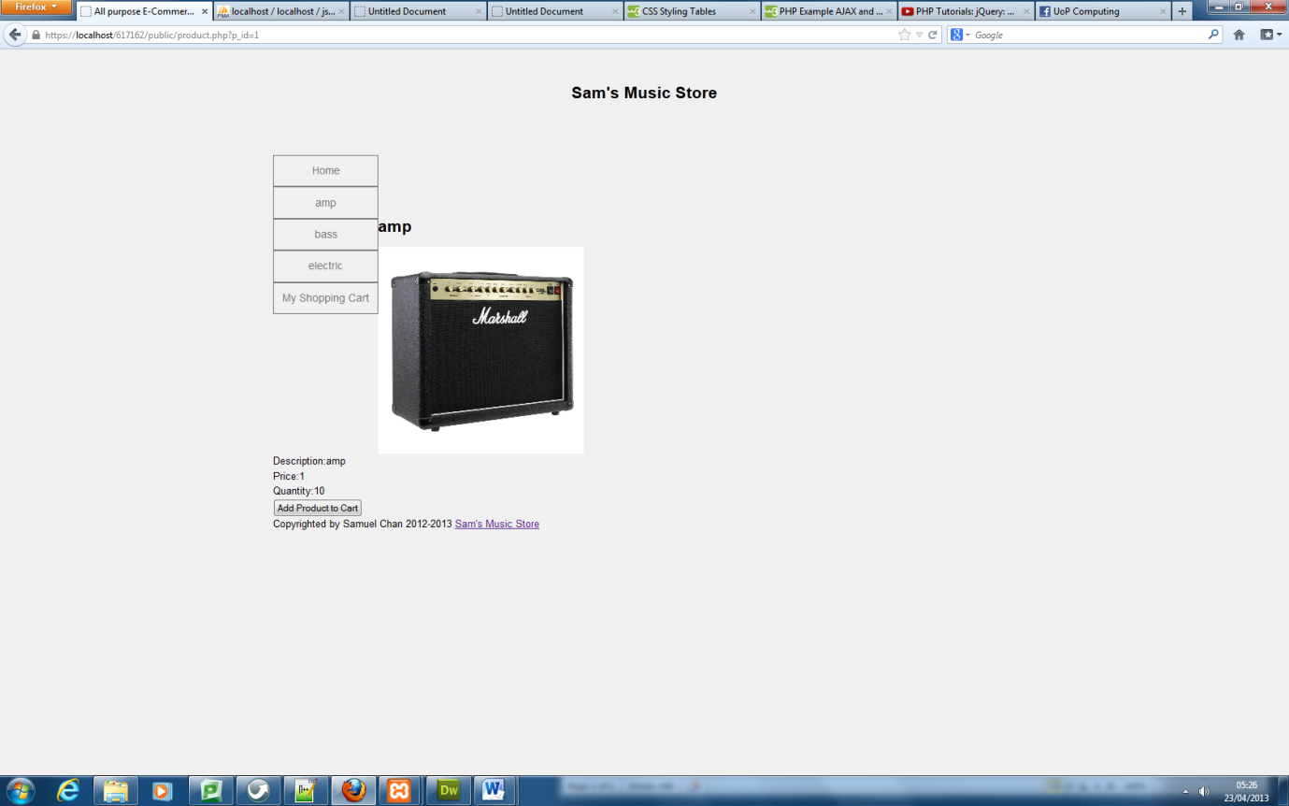The CSS needs much work where I failed to allocate enough time because I felt the websites functionality was a much higher priority.

Product name links to full product description with image

The final procedure for the customer is the checkout page where the final cart price is displayed where the user needs to fill in their personal and financial details to be recorded into the database. A message is provided so the user can see the payment was successful.

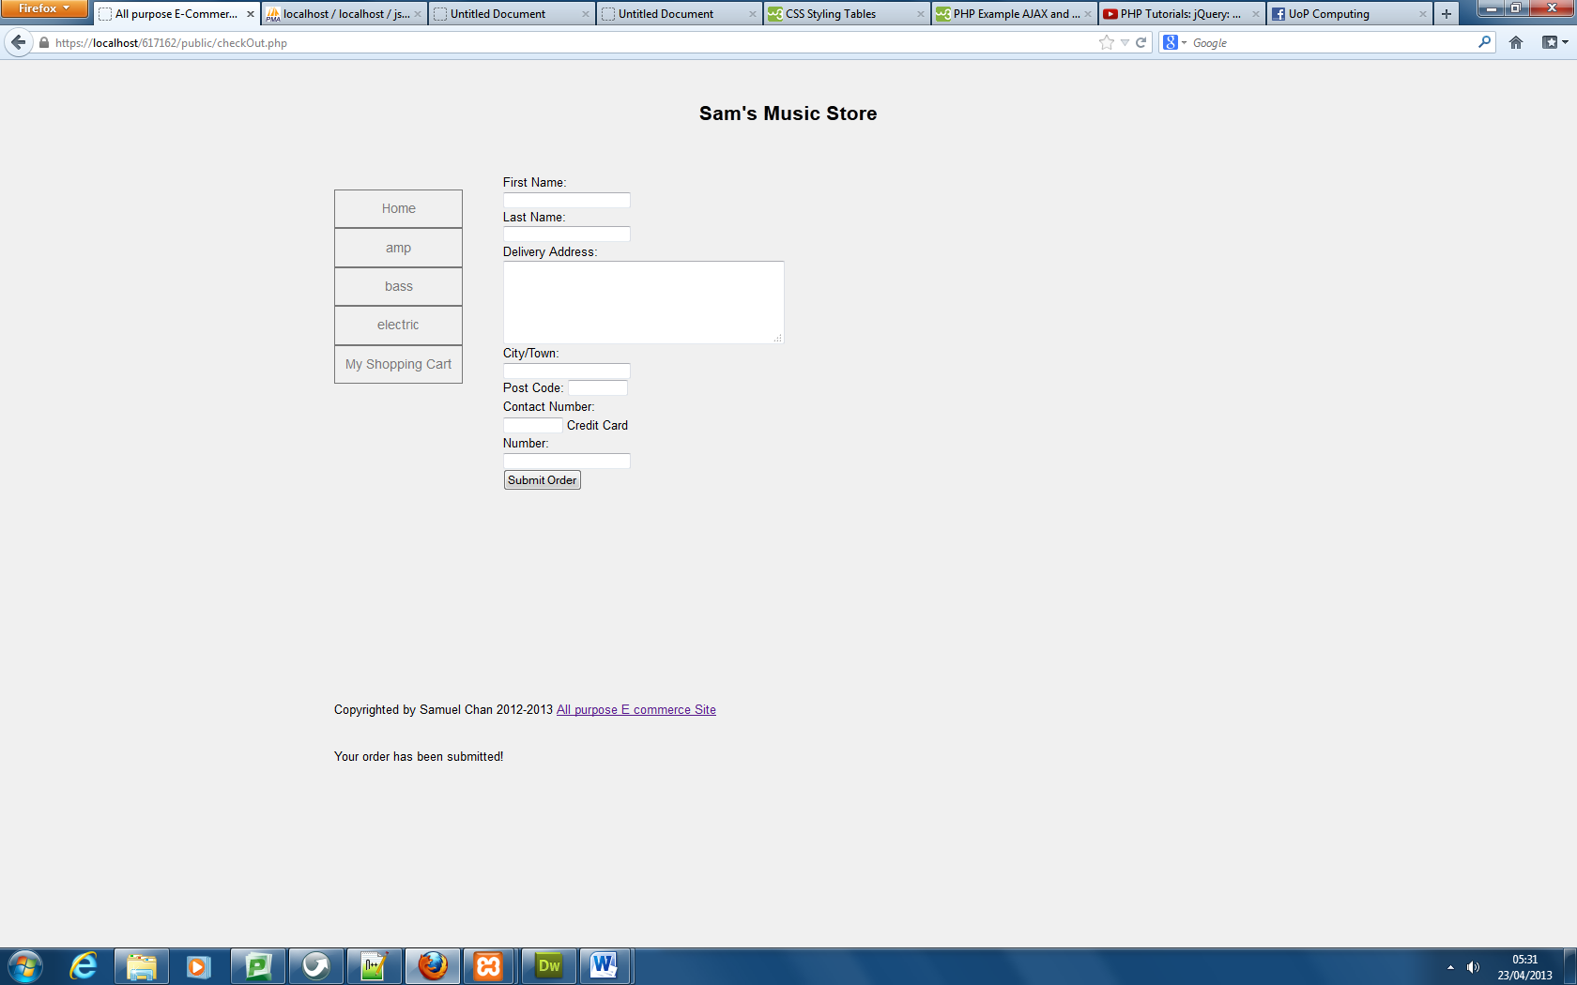

Product name links to full product description with image

For the admin section, the user is brought to a main menu where they have options to choose from such as add, edit, remove and display products. They can also add and remove categories whilst also viewing sales reports of products sold along with total sales made each month and year. A simple menu is all that’s needed as it looks bare but admin needs to instantly find what they need in the navigation.

Adding a product is done by the client filling in a form where all fields must be entered in order for the product to be successfully added to the database. The categories can be chosen through a drop down menu which are generated from the database if any categories exist in there yet. Images are optional to put with the product however they are saved in a sub-directory within the admin folder. The user is prompted whether they have chosen an incorrect image type or haven’t chosen one at all. This prevents empty data being sent to the database.

The managing product page will show all products that have been added to the database. They are given few details such as name and quantity to remind them what item they are either editing or removing. “Edit” will lead the user to an edit page containing the products existing information for the user to read and understand why they are changing the product. Here they are able to change all product details such as input new stock that has been delivered and replace the existing image. The “remove” link simply deletes the product from the database.

“Display all Products” was made to let the admin see all the products and all their details such as date added. It gives them an overview of the every product they are selling. Client staff can then see when stock was added and stock levels remaining.

“add/remove category” basically adds and deletes categories from the database for it to be displayed on the public pages.

“Sales Reports” lets the admin see total value of sales over periods of time whilst allowing them to see all transactions made on public pages

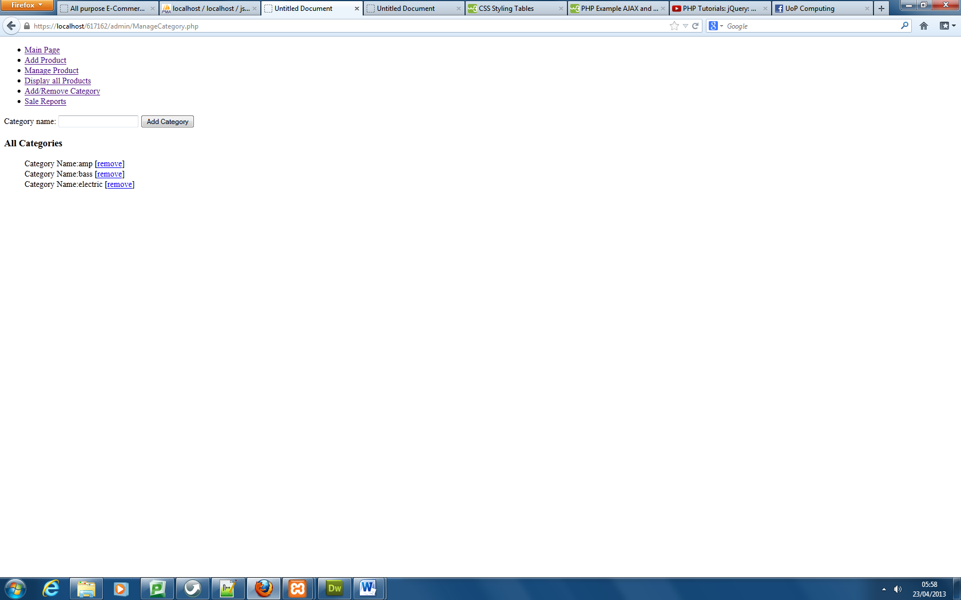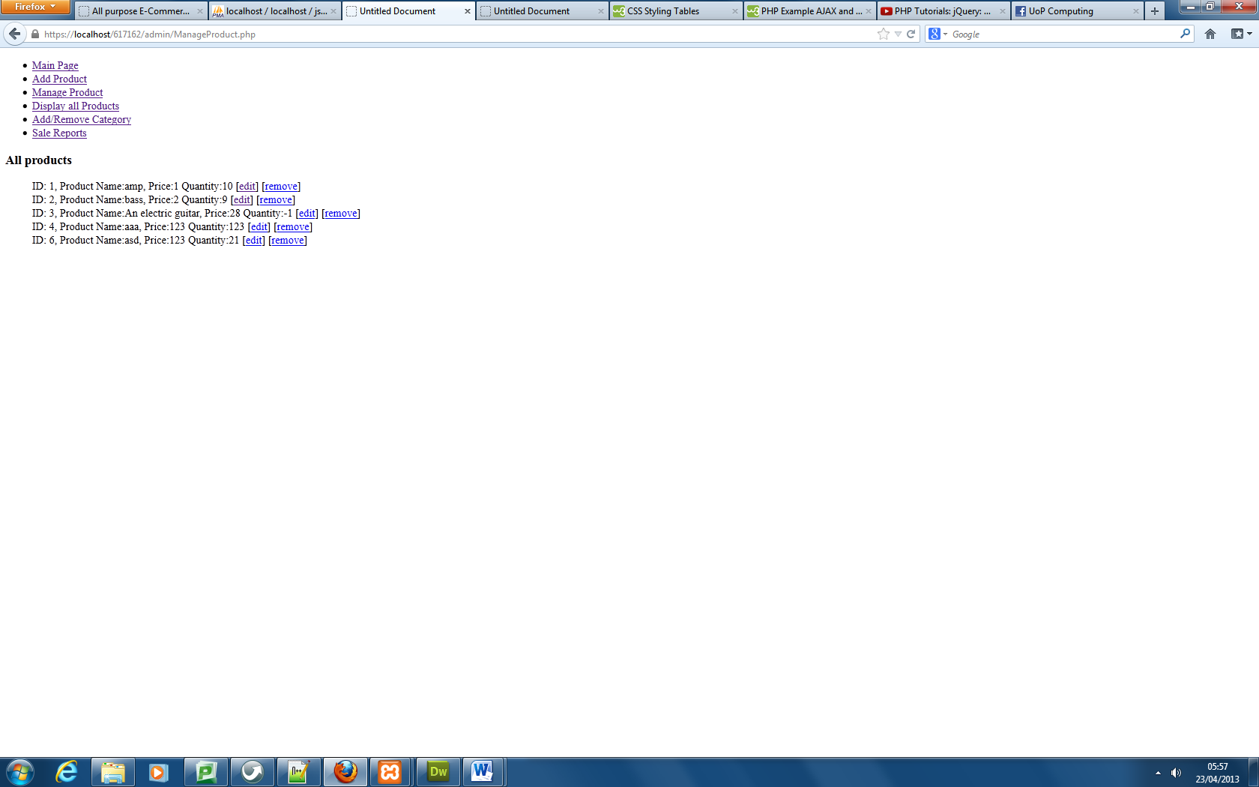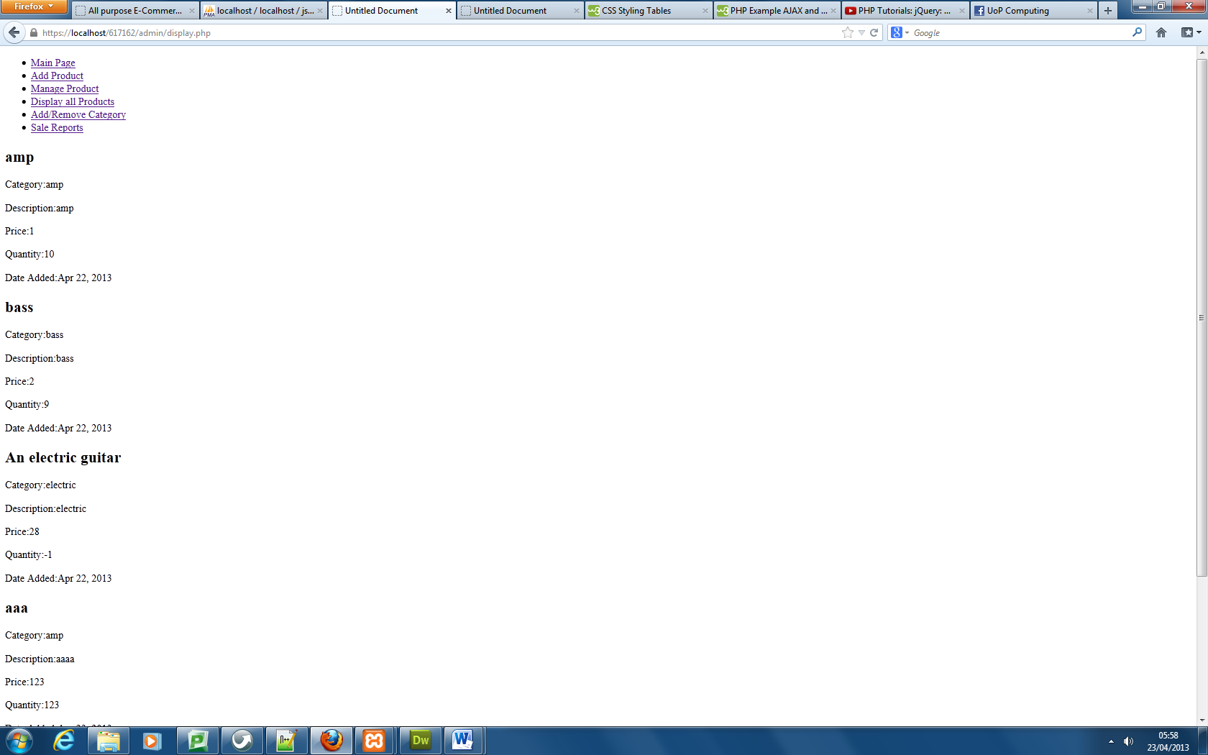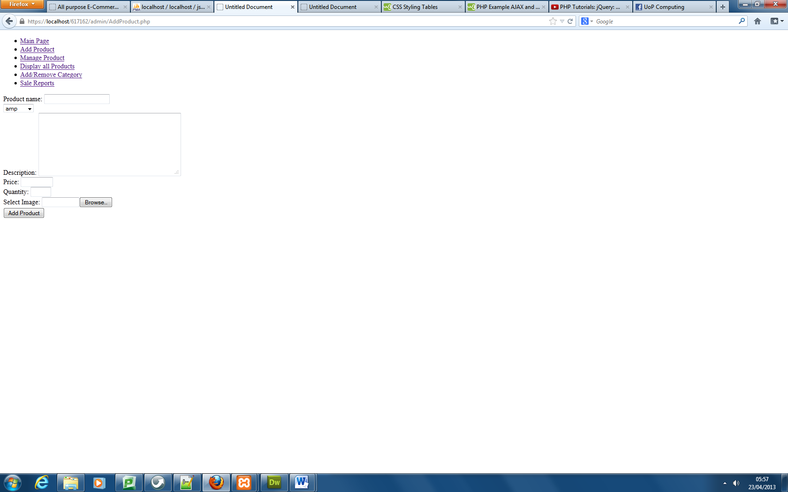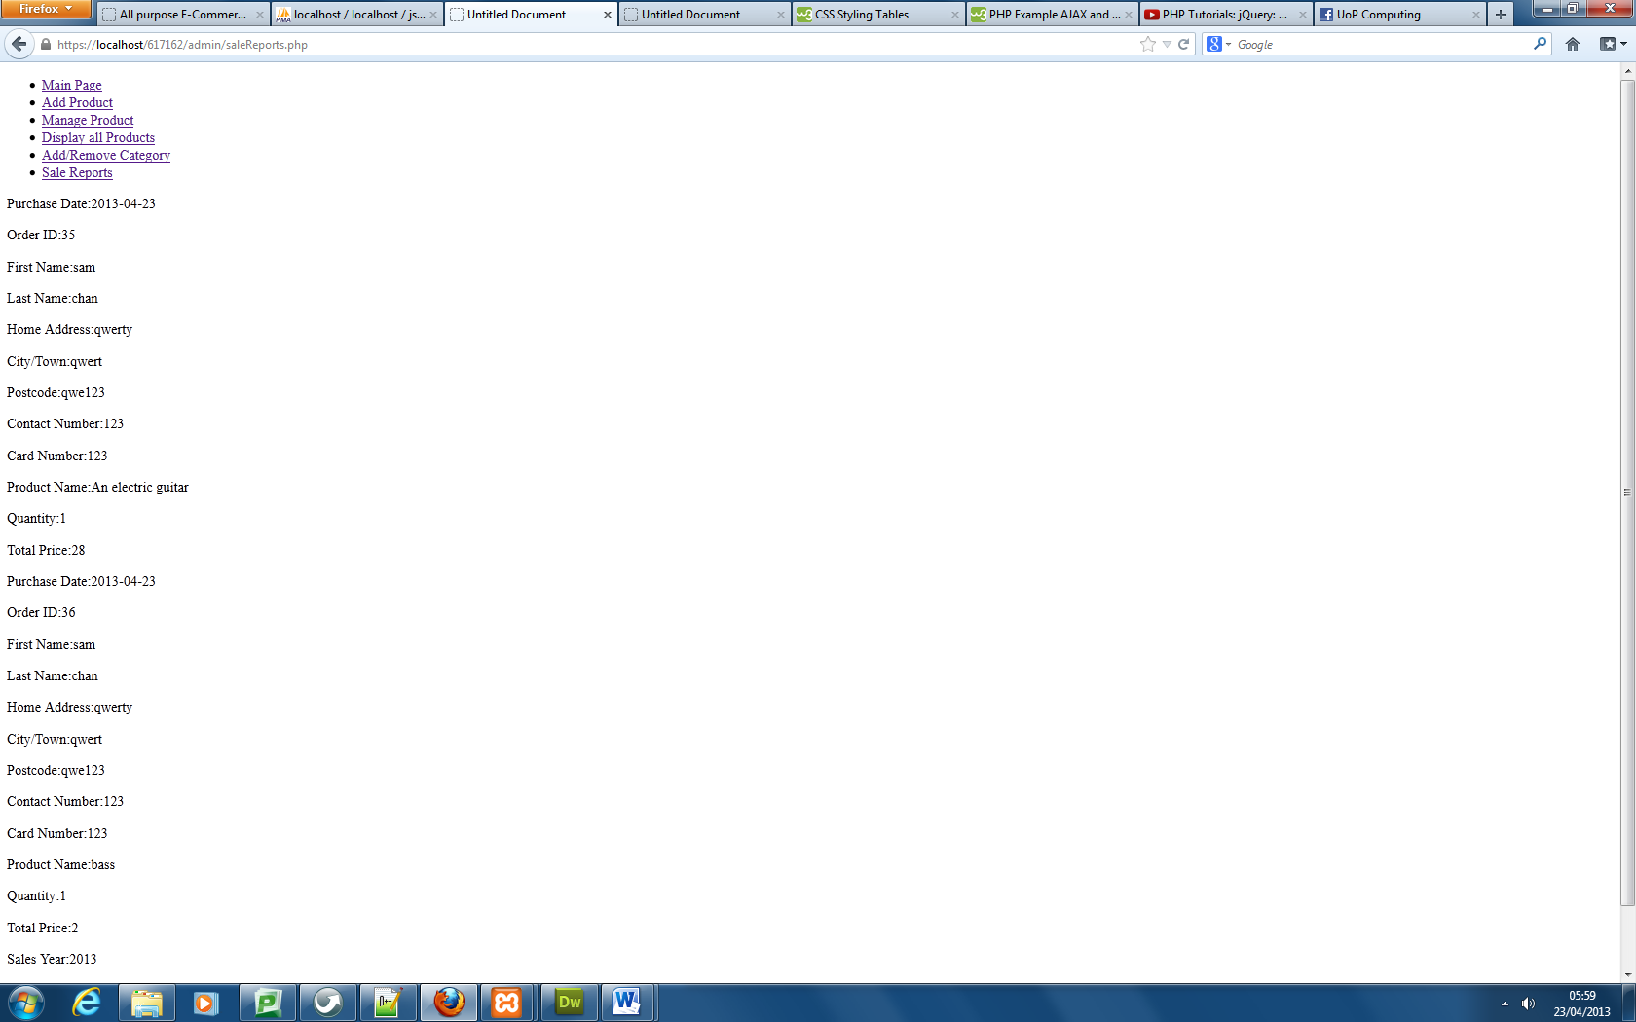

Add and remove category page

View all customer sales and total sales over a period of time.

Manage products to delete or edit their details

Display all product that exist in the database

Form to add product